**Docker:**

* Docker is the world’s leading software container platform.
* Docker makes the process of application deployment very easy and efficient and resolves a lot of issues related to deploying applications.
* Docker is a tool designed to make it easier to deploy and run applications by using containers.
* Docker gives you a standard way of packaging your application with all its dependencies in a container.
* Containers allow a developer to package up an application with all of the parts it needs, such as libraries and other dependencies, and ship it all out as one package.

[**Virtualization**](https://www.google.com/search?rlz=1C1GCEA_enIN866IN866&sxsrf=ALeKk00BQPzK7gfEOOSc6kIuoJ_YWlGHjg:1587953338116&q=virtualization&spell=1&sa=X&ved=2ahUKEwjQno2Vw4fpAhWPxjgGHYfDBdAQkeECKAB6BAgWECc): This is a technology where will create Virtual Machines with necessary configurations (OS + Applications + Bins + Libs).

* This is very heavy: Takes lot of memory and costly.
* We need to take care of all required configurations and their versions.
* Older techniques.

**Containerization**: This is a technology where will create container on the top of container engines.

* Very light weight and required only 1 VM (we can create multiple container including Hub and Nodes in single VM).
* No OS+ Applications + Libs +Bins
* Will created container with the help of docker images.

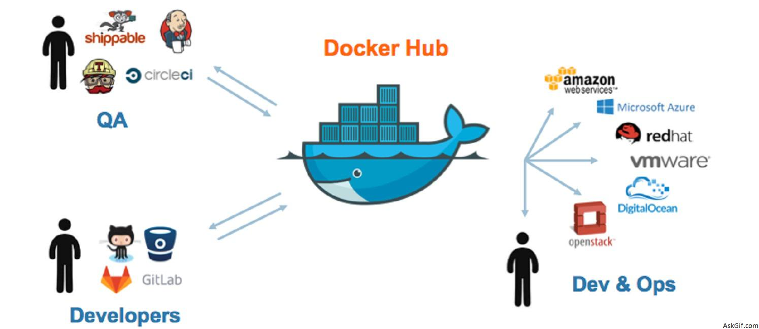

**Docker Hub**: It is a central repository for docker where all the images are available, and we can pull and push the images.

**Docker Images**: A Docker container image is a lightweight, standalone, executable package of software that includes everything needed to run an application: code, runtime, system tools, system libraries and settings.

**Docker container**: A container is a standard unit of software that packages up code and all its dependencies, so the application runs quickly and reliably from one computing environment to another.

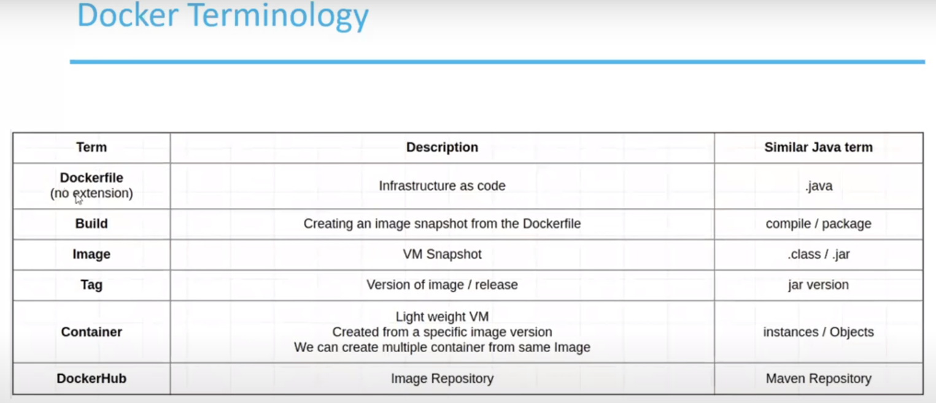

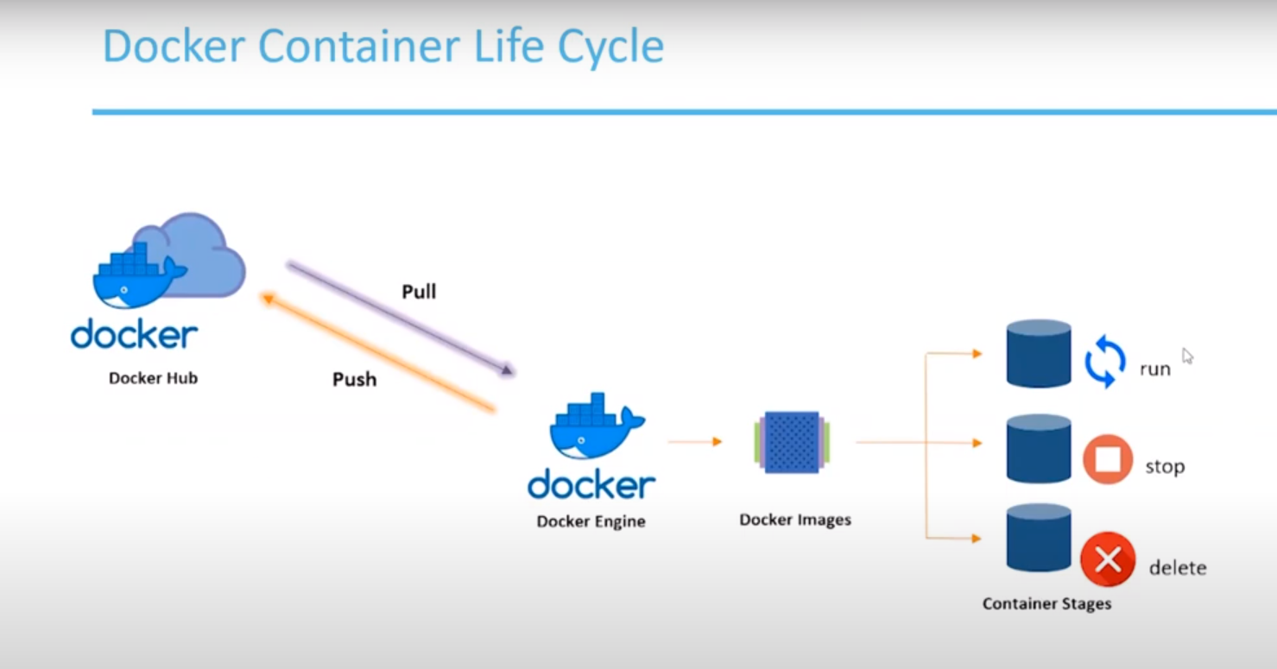

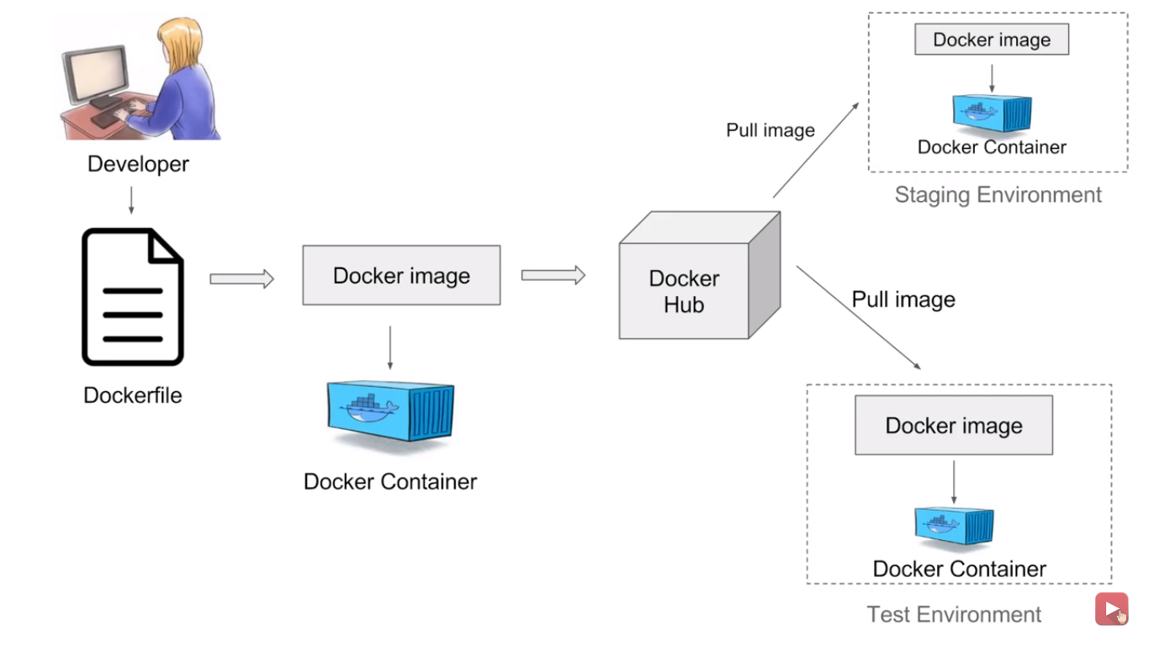

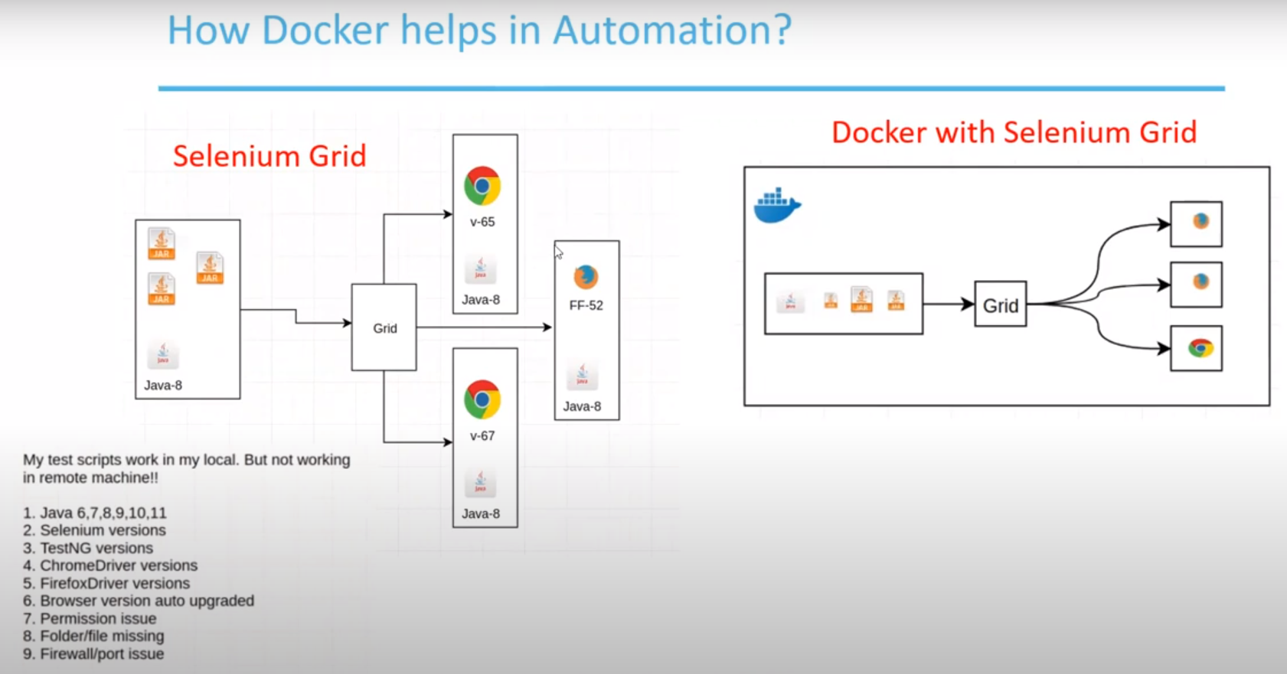

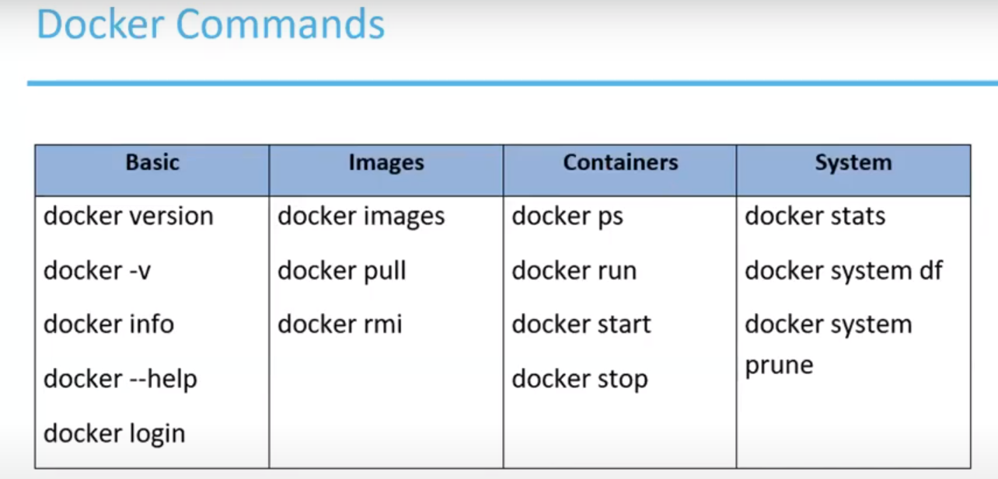 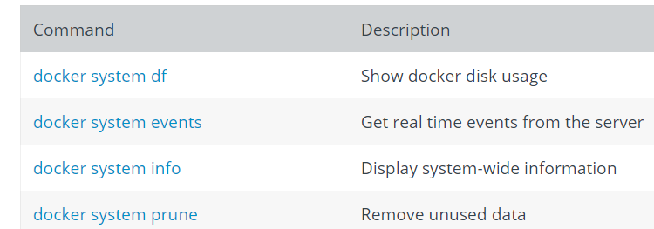

docker run -it imageName : it indicates interactable

ps- process status

**Pull the image: selenium/standalone-chrome**

**Run the container:**

docker run -d -p 4444:4444 -v /dev/shm:/dev/shm selenium/standalone-chrome:latest

-d indicates: will run in backend

-p: port number

**Note**: Container should up and running for execution.

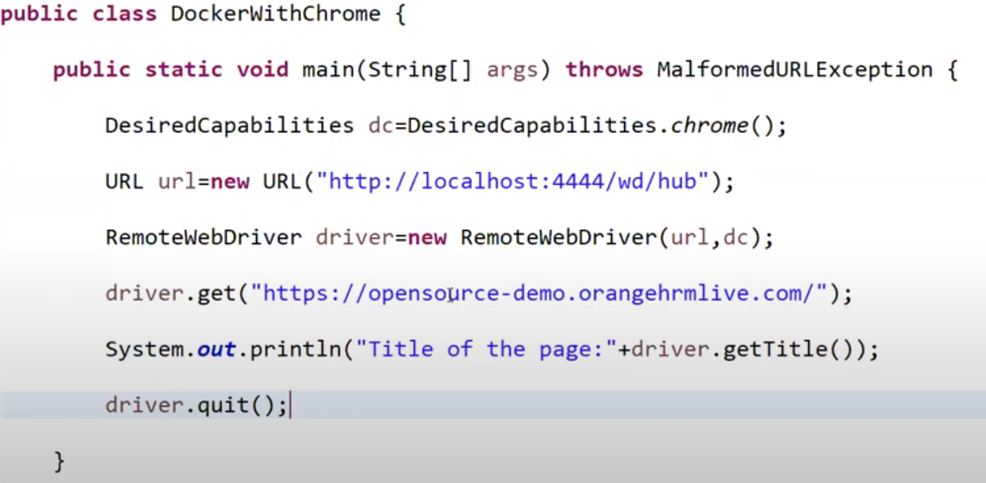

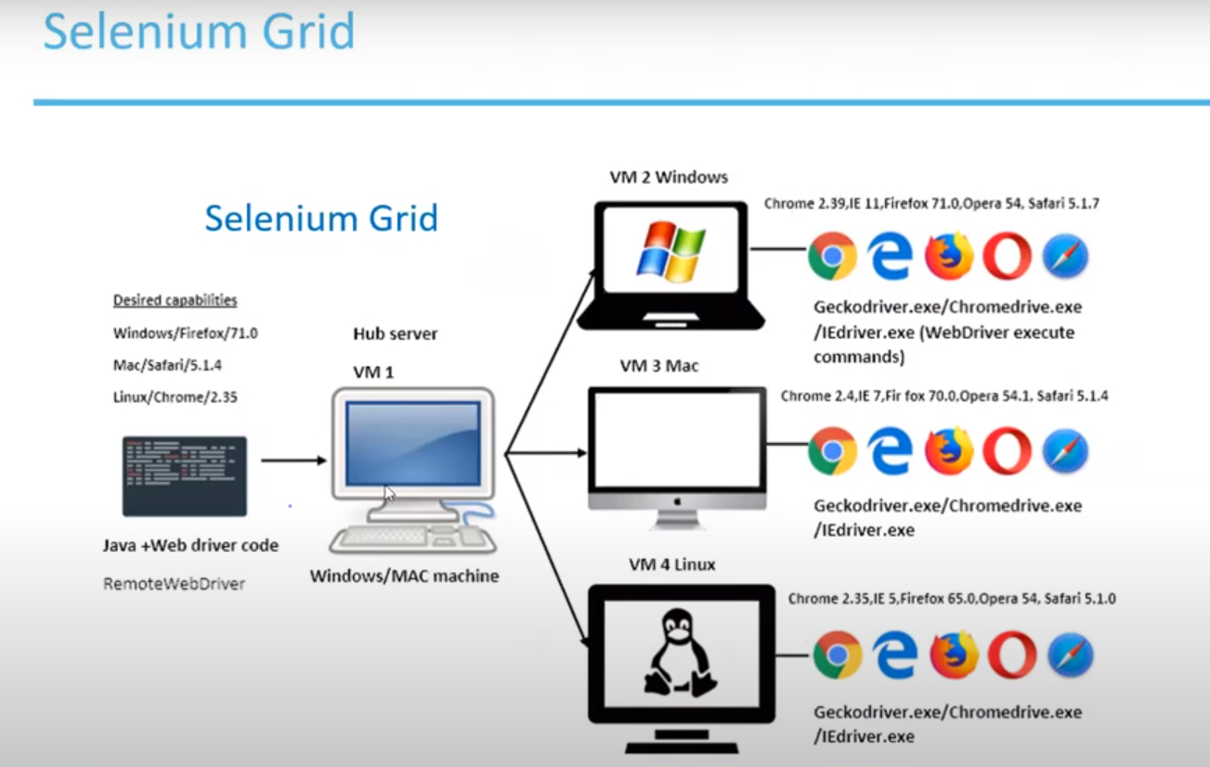

As per the desired capabilities in our code, hub will routed our execution to respective node.We have 4 VM’s (1- Hub, 3-Nodes) and each VM should have proper configuration and installations then only our script will execute, and this is the biggest disadvantages.

­

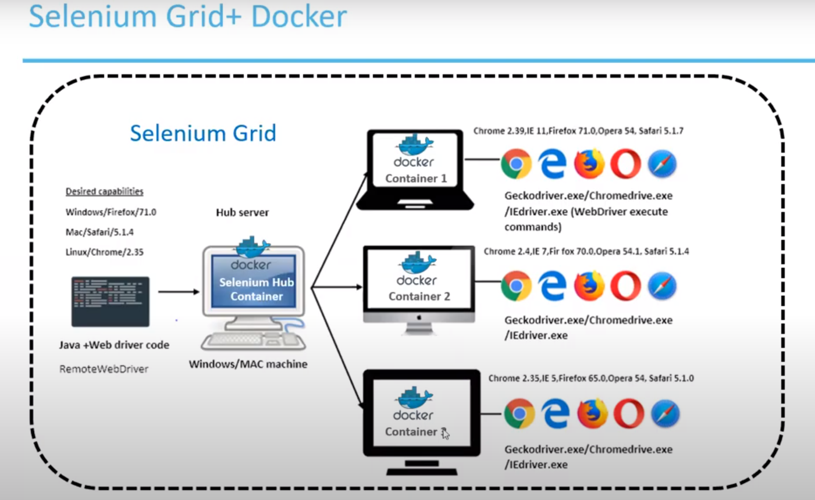

Here all the containers are created by images and this is in single VM only.

* Now we need to create this Hub-Node environment, and this will do using **docker-compose.yaml** file and this will create container and attach nodes to hub.
* Go to file location and run this file using: **docker-compose up**
* Go to grid console and check grid is running and nodes are associates to hub.
  + <http://localhost:4444/grid/console>
* We can increase number of nodes: **docker-compose scale chrome/firefox=3**
* Execute your test.
* To stop the grid and cleanup the container: **docker-compose down**

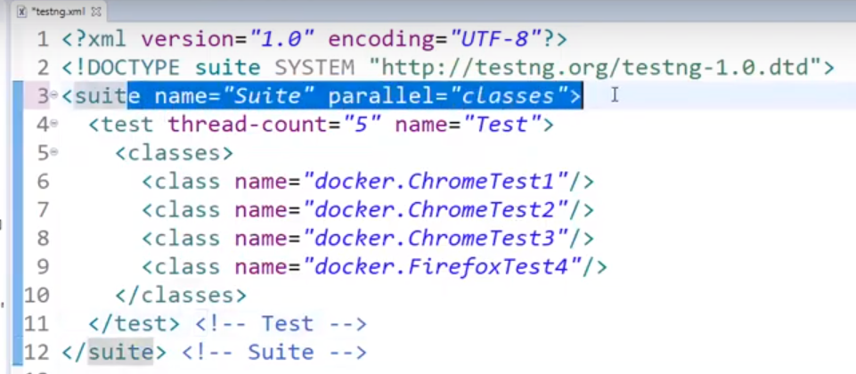

But here also we are starting and stopping docker manually.

Now we will create bat files and execute through code using java.

We need 3 files:

* docker-compose.yaml
* start_docker.bat:
  + go to location of compose file and run **docker-compose up**
* stop_docker.bat:
  + go to location of compose file and run **docker-compose down**

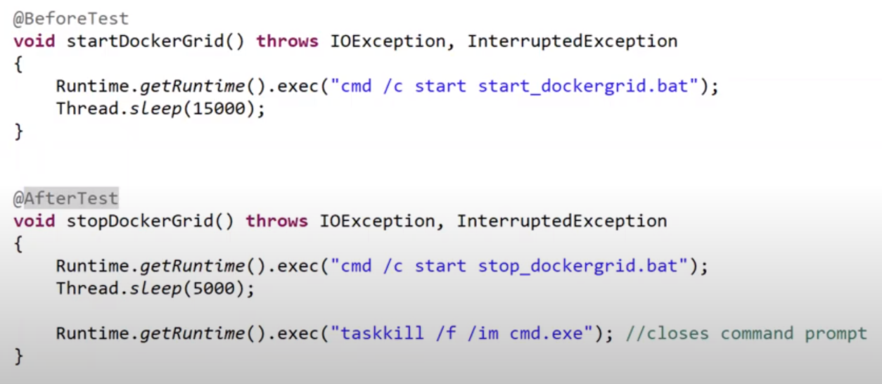

**Docker Uses**

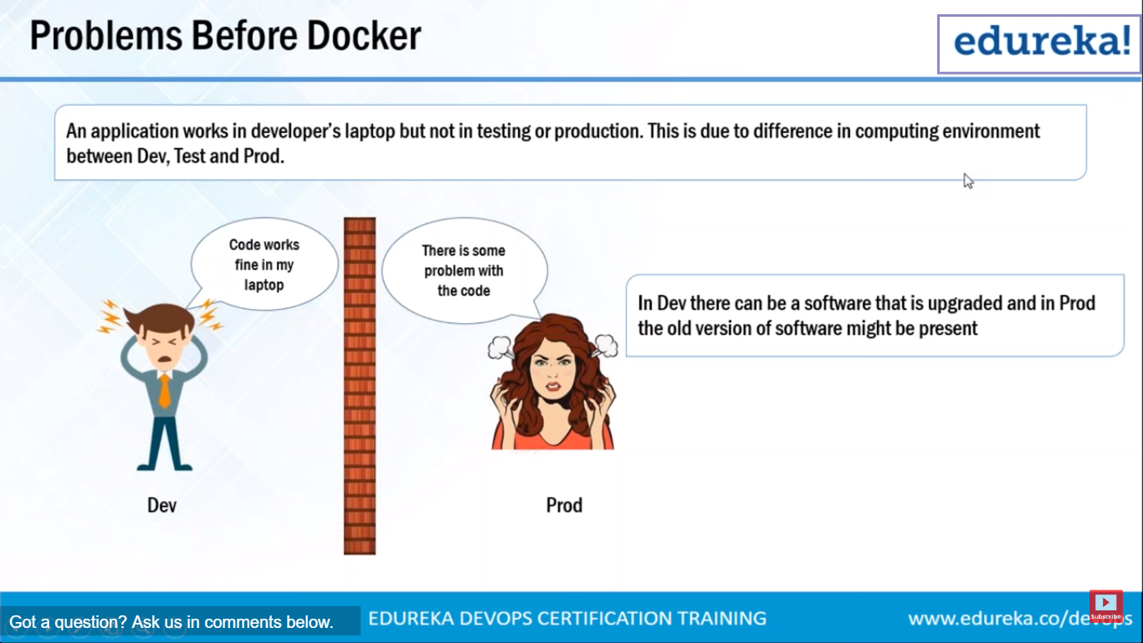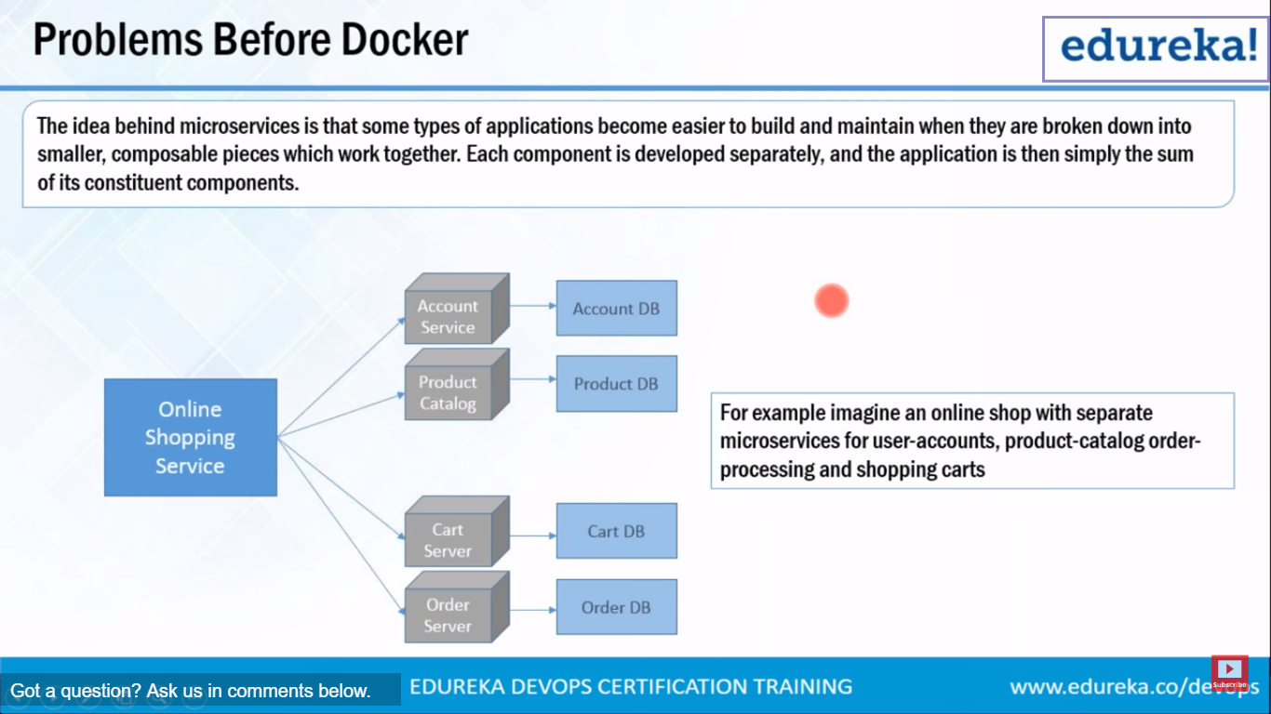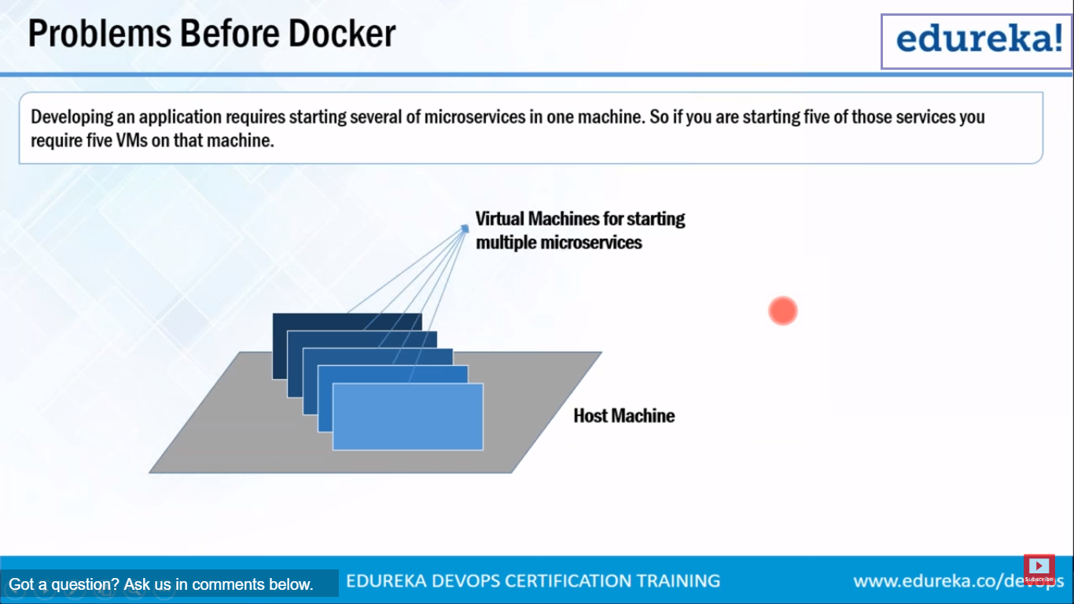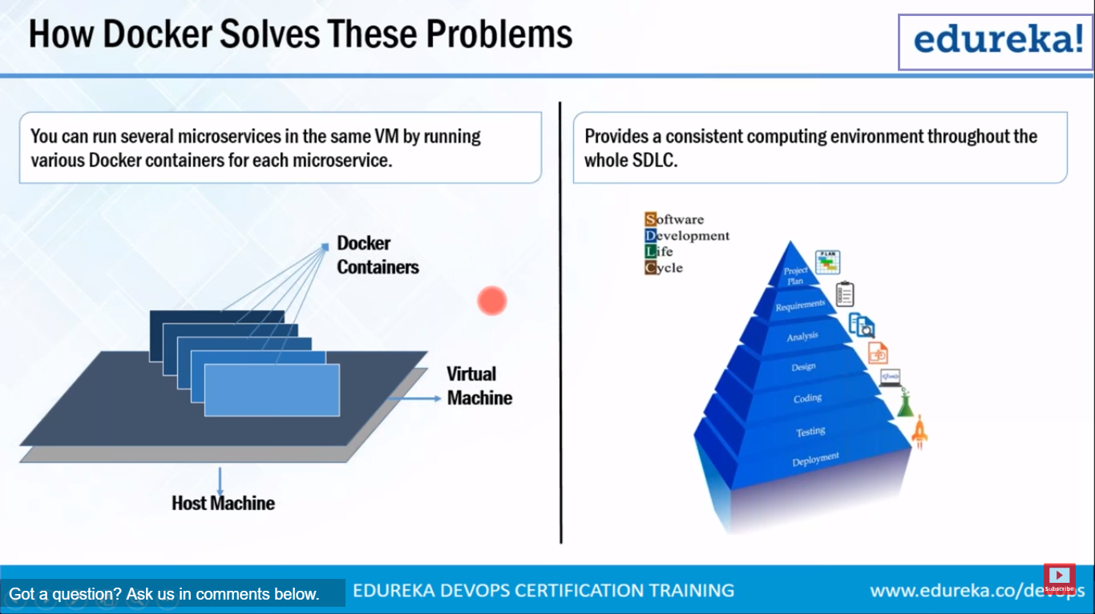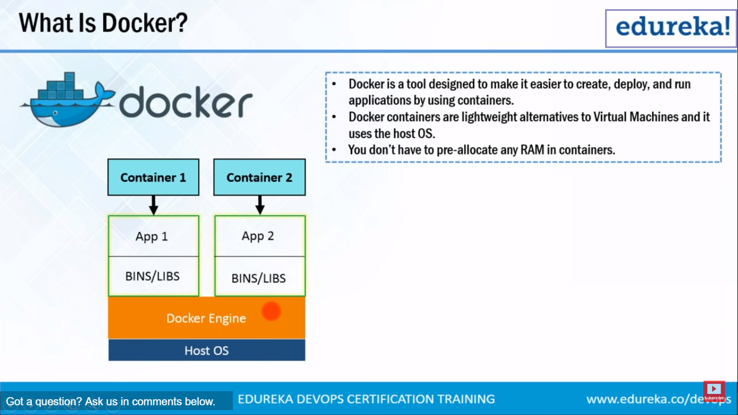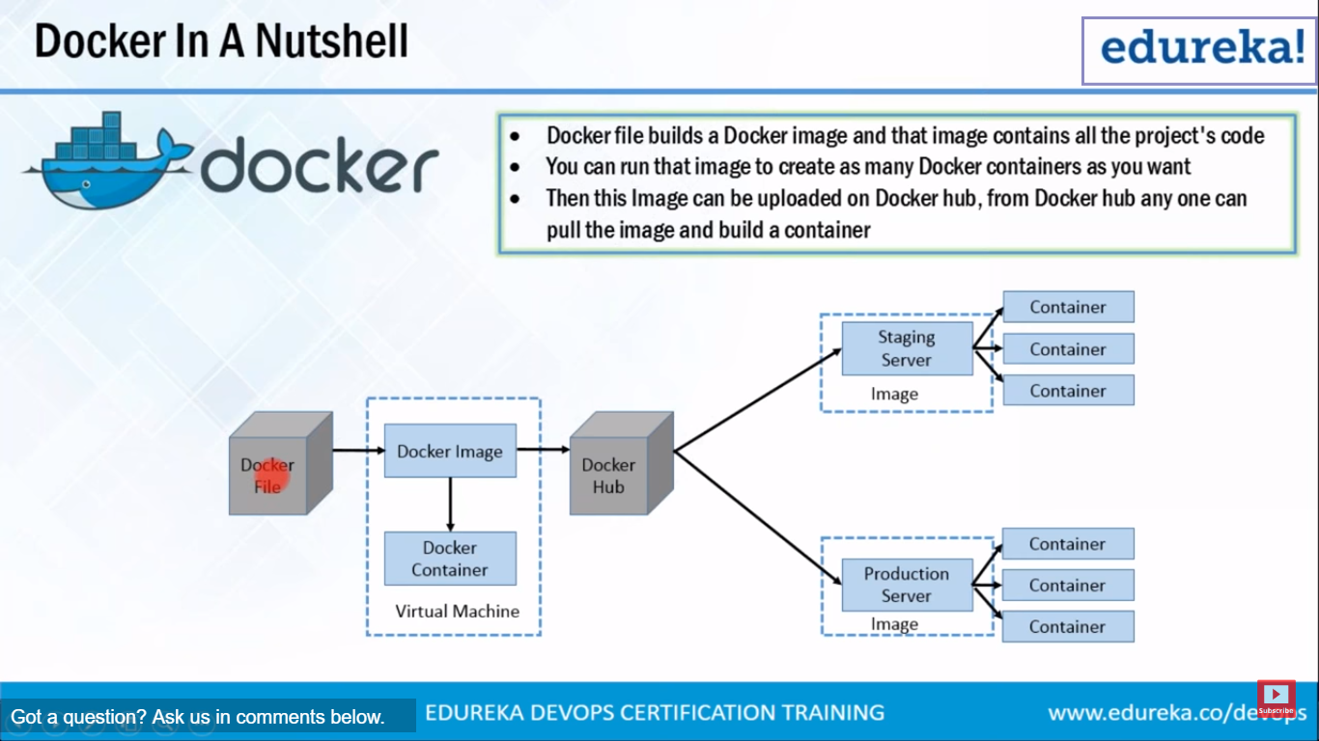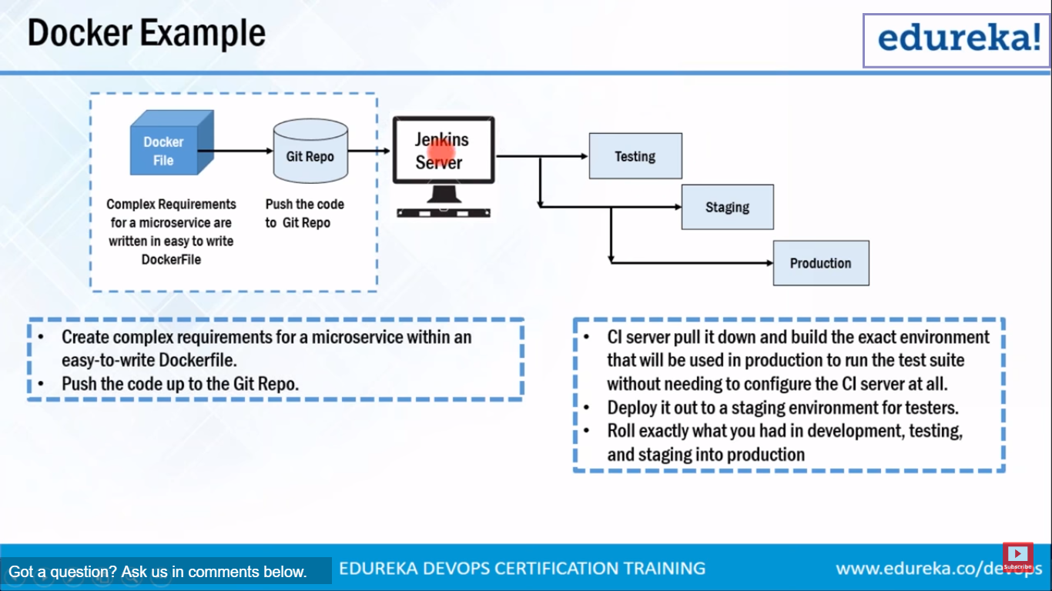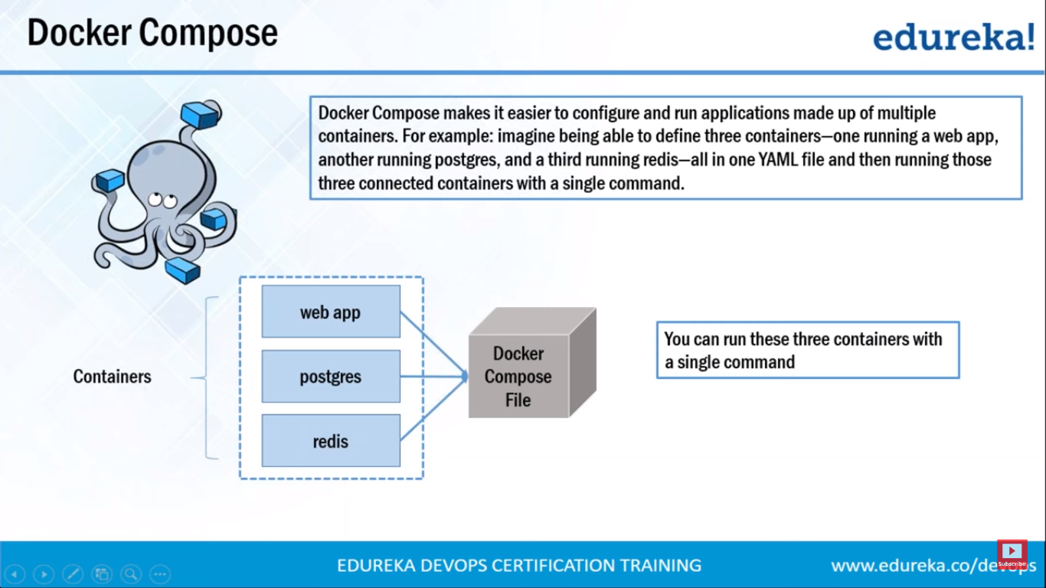

* 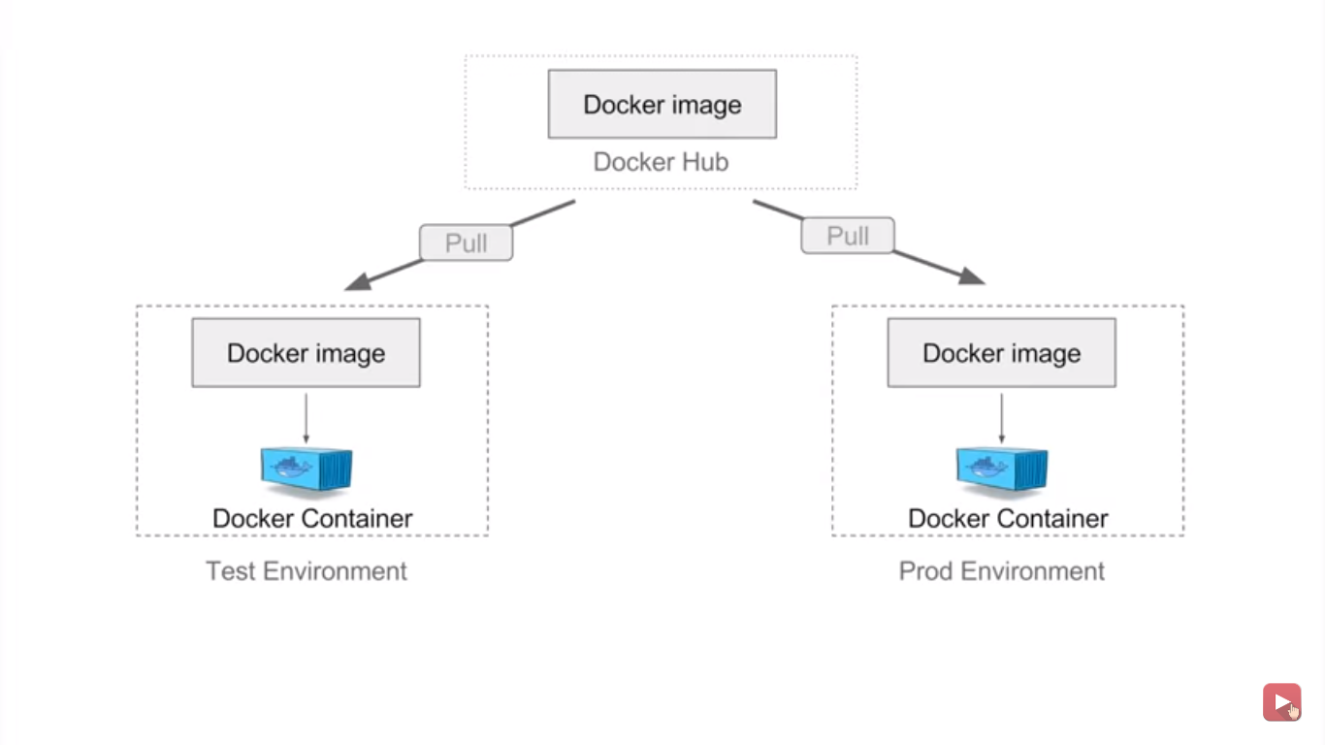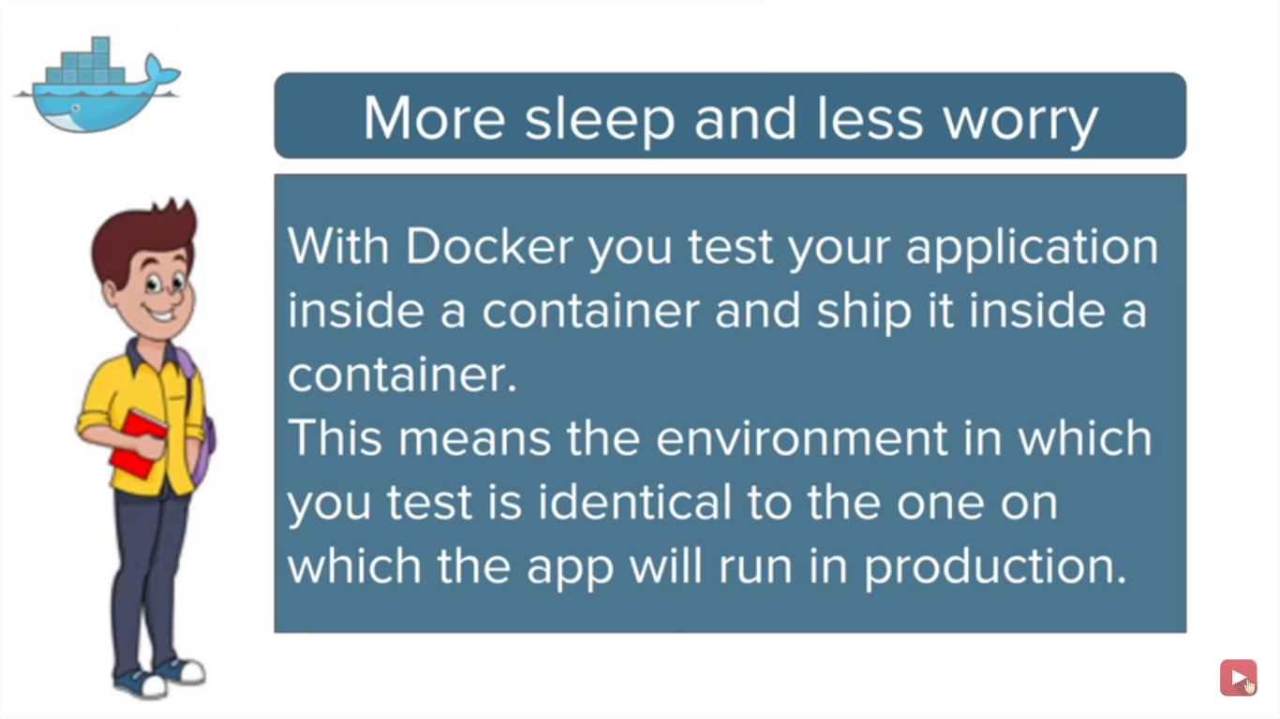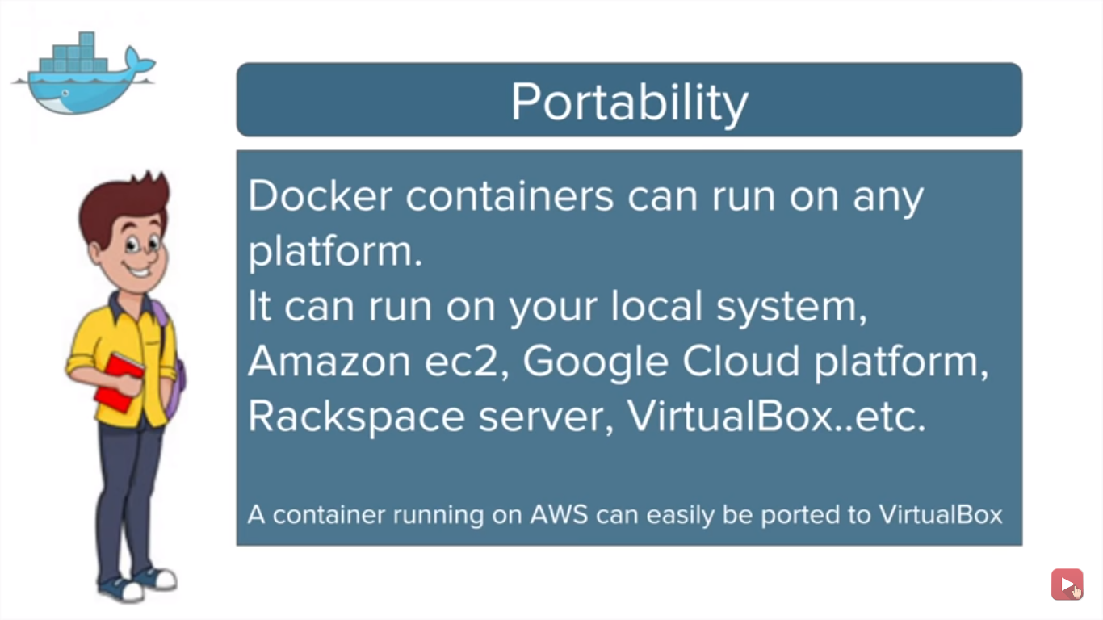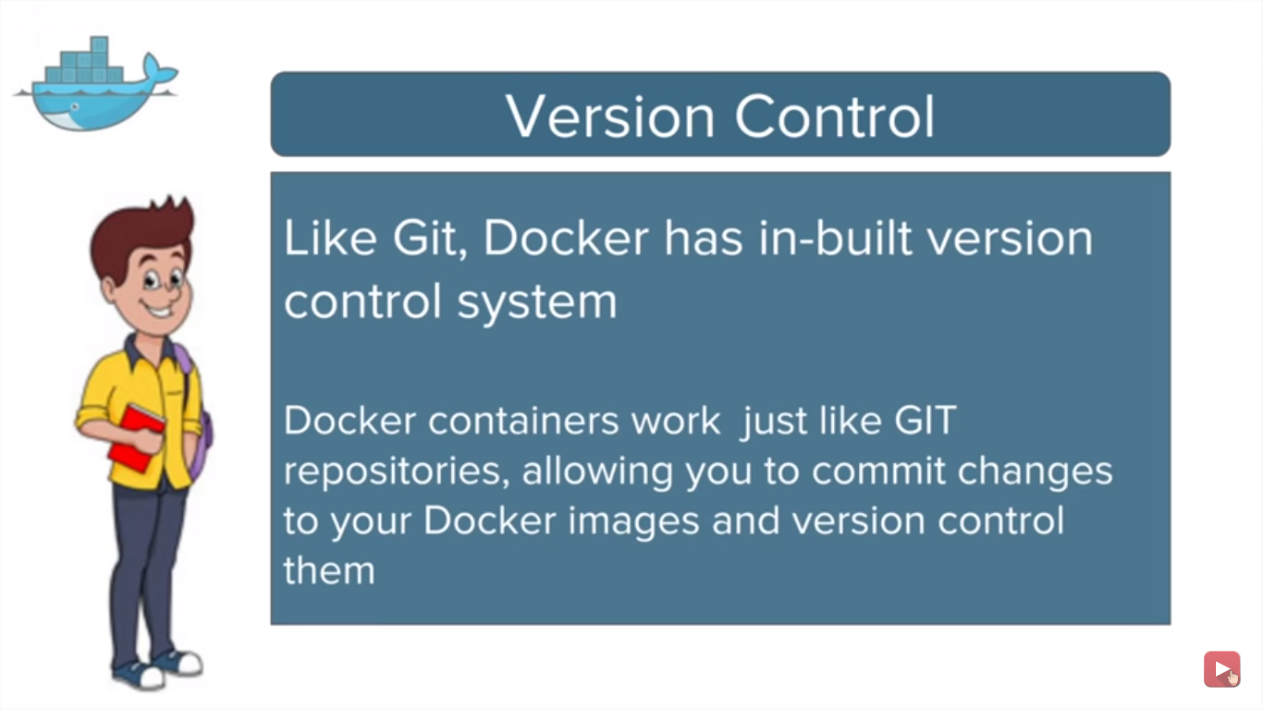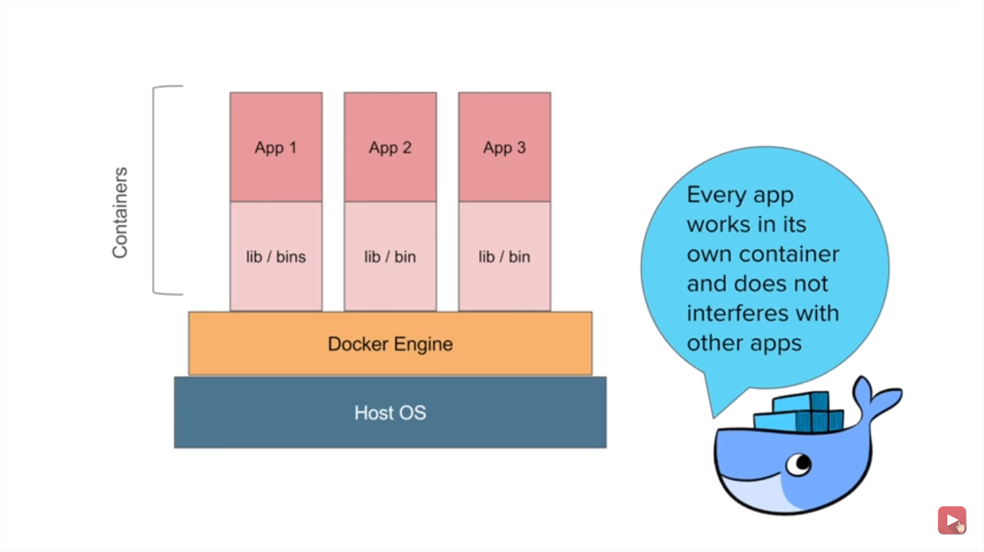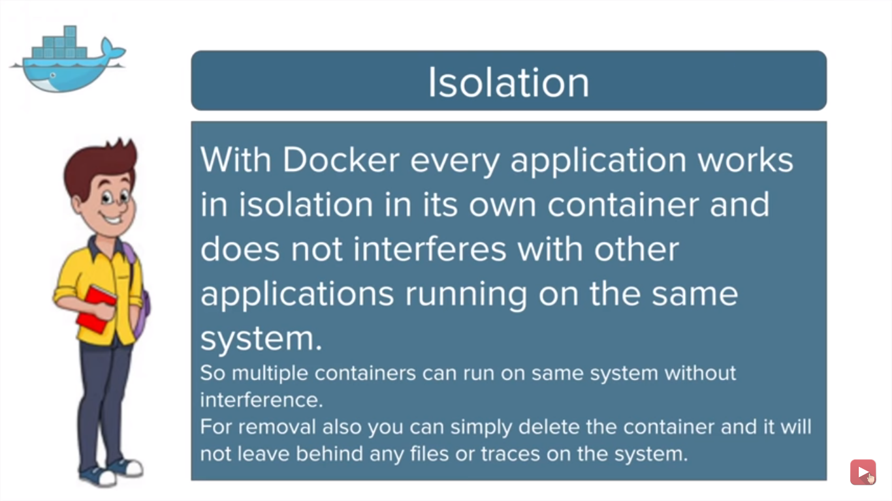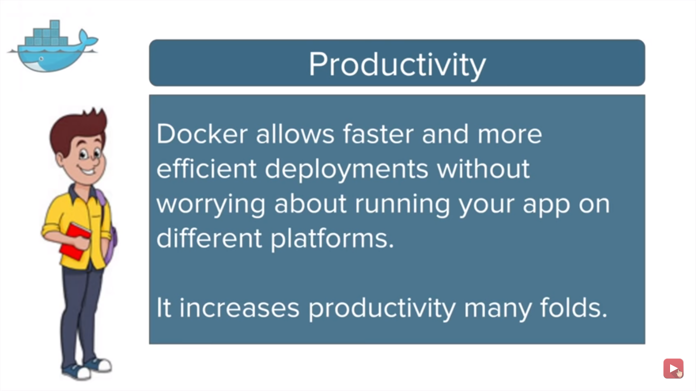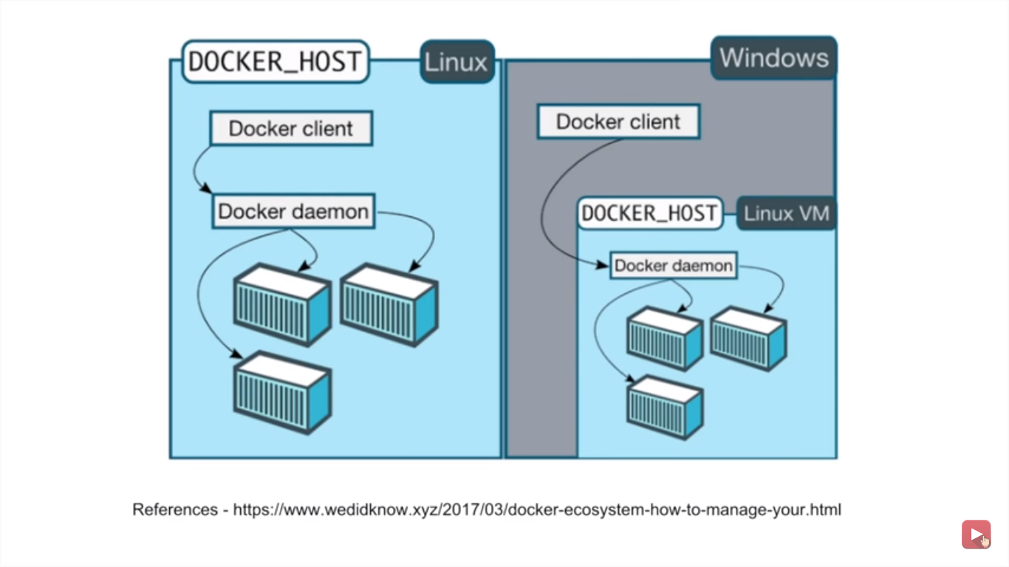Containers and images created with Docker for Windows are shared between all user accounts on machines where it is installed. This is because all Windows accounts use the same VM to build and run containers.
* Dangling images- which are not associated with running container.
* A container image is a lightweight, stand-alone, executable package of a piece of software that includes everything needed to run it: code, runtime, system tools, system libraries, settings.

Features of Containers:

* Are lightweight.
* Fewer resources are used.
* Booting of containers is very fast.
* Can start, stop, kill, remove containers easily and quickly.
* Operating System resources can be shared within Docker.
* Containers run on the same machine sharing the same Operating system Kernel, this makes it faster